**Phase 3 DBMS Lab Project**

**Sir Khizer Hayat**

**O9**

**L1F20BSSE0291**

**Muhammad Saad Arif Dhillon**

**_____________________ ____________________**

**Supermarket Grocery Store**

DDL, DML & Queries

-- ddl & dml commands file

-- dbms lab project phase 3

-- L1F20BSSE0291

create database dbLabProject;

use dbLabProject;

create table product(

productCode varchar (200) not null primary key,

productCost varchar (200),

productCompany varchar (200),

productType varchar (200),

productExpiry varchar (200),

paymentID varchar (200));

create table store(

storeNo varchar (200) not null primary key,

storeContact varchar (200),

storeLocation varchar (200),

storeName varchar (200),

ownerID varchar (200));

create table owner(

ownerID varchar (200)not null primary key,

ownerName varchar (200));

create table login(

loginID varchar (200)not null primary key,

loginPass varchar (200),

ownerID varchar (200));

create table customer(

custID varchar (200)not null primary key,

custName varchar (200),

custContact varchar (200),

custAdress varchar (200),

empID varchar (200));

create table employee(

empID varchar (200) not null primary key,

empName varchar (200),

empContact varchar (200),

empAdress varchar (200),

empLeaves int (200));

create table supplier(

suppID varchar (200) not null primary key,

suppName varchar (200),

suppEmail varchar (200),

suppContact varchar (200),

suppAdress varchar (200),

empID varchar (200));

create table delivery(

deliveryStatus varchar (200),

deliveryAdress varchar (200),

custID varchar (200));

create table payment(

paymentID varchar (200) not null primary key,

paymentAmmount varchar (200),

custID varchar (200));

create table orders(

orderID varchar (200)not null primary key,

orderNo varchar (200),

custID varchar (200));

alter table product add foreign key (paymentID) references payment(paymentID);

alter table store add foreign key (ownerID) references owner(ownerID);

alter table login add foreign key (ownerID) references owner(ownerID);

alter table customer add foreign key (empID) references employee(empID);

alter table supplier add foreign key (empID) references employee(empID);

alter table delivery add foreign key (custID) references customer(custID);

alter table orders add foreign key (custID) references customer(custID);

alter table payment add foreign key (custID) references customer(custID);

-- dml commands

insert into product (productCode,productCost,productCompany,productType,productExpiry,paymentID)

values('10000','60','dawn','bread','10-12-2023','1001'),

('10001','600','seafoods','fish','10-12-2024','1002'),

('10002','200','zarafa rice','rice','20-10-2024','1003'),

('10003','900','mundial','olive oil','15-09-2025','1004'),

('10004','50','hashmi','surma','12-11-2023','1005'),

('10005','150','olpers','youghrt','10-05-2023','1006'),

('10006','100','olpers','milk','10-03-2023','1007'),

('10007','200','fruitmart','apples','03-03-2023','1008'),

('10008','250','vegimart','carrots','02-11-2023','1009'),

('10009','60','dawn','bread','10-12-2023','1010');

-- delete from product where productCode between '10000' and '10009';

insert into store(storeNo,storeContact,storeLocation,storeName)

values('10','3100000','karachi','metro'),

('11','3100001','lahore','metro'),

('12','3100002','islamabad','metro');

insert into owner(ownerID,ownerName)

values('O1','ali'),

('O2','abdullah');

insert into employee(empID,empName,empContact,empAdress,empLeaves)

values('100','Furqan','31000','muzafrabad','0'),

('101','Sajid','31001','bagwanpura','2'),

('102','Majid','31002','lahore','1'),

('103','Hamid','31003','wazirabad','5'),

('104','Fareed','31004','karachi','2'),

('105','Imran','31005','islamabad','4'),

('106','Nawaz','31006','quetta','1'),

('107','Shahbaz','31007','peshawar','0'),

('108','Hamza','31008','kaleemabad','7'),

('109','Saleem','31009','sirinagar','2');

insert into login(loginID,loginPass)

values ('ali','100'),

('abdullah',101),

('Furqan',102),

('Sajid',103),

('Majid',104),

('Hamid',105),

('Fareed',106),

('Imran',107),

('Nawaz',108),

('Shahbaz',109),

('Hamza',110),

('Saleem',111);

insert into payment

values('1001','500','20000'),

('1002','200','20001'),

('1003','800','20002'),

('1004','250','20003'),

('1005','350','20004'),

('1006','400','20005'),

('1007','260','20006'),

('1008','880','20007'),

('1009','920','20008'),

('1010','100','20009');

insert into customer(custID,custName,custContact,custAdress,empID)

values('20000','usman','34501','sialkot','100'),

('20001','umer','34502','pakpatan','101'),

('20002','ahmed','34503','ajmeershareef','102'),

('20003','arslan','34504','qalandarabad','103'),

('20004','anwar','34505','sultanabad','104'),

('20005','saleem','34506','turkmanistan','105'),

('20006','shabir','34507','tibit','106'),

('20007','ducky bhai','34508','misar','107'),

('20008','shahmeer','34509','dubai','108'),

('20009','bilal','34510','newyork','109');

-- delete from customer where custID between 20000 and 20009;

insert into supplier (suppID,suppName,suppEmail,suppContact,suppAdress)

values('300','Faisal','faisal@gmail.com','30600','multan'),

('301','Fawad','fawad@gmail.com','30601','sheikhupura'),

('302','Ali Zafar','alizafar@gmail.com','30602','bhaatiyan'),

('303','Feroze','feroze@gmail.com','30603','dera gujran'),

('304','Emmad','emmad@gmail.com','30604','canal view'),

('305','Danish','danish@gmail.com','30605','wapda town'),

('306','Hamza','hamza@gmail.com','30606','city housing'),

('307','Messi','messi@gmail.com','30607','G magnolia'),

('308','Sultan','sultan@gmail.com','30608','muhalla bakhtiyan'),

('309','Ronaldo','ronaldo@gmail.com','30609','harbanspura');

insert into delivery (deliveryStatus,deliveryAdress,custID)

values ('complete','C420','20000'),

('pending','A220','20001'),

('complete','C202','20002'),

('complete','B103','20003'),

('pending','D404','20004'),

('complete','A111','20005'),

('complete','B004','20006'),

('pending','D303','20007'),

('complete','A502','20008'),

('pending','C332','20009');

-- delete from delivery where custID is null;

insert into orders (orderID,orderNo,custID)

values('1000','500',20000),

('1001','501',20001),

('1002','502',20002),

('1003','503',20003),

('1004','504',20004),

('1005','505',20005),

('1006','506',20006),

('1007','507',20007),

('1008','508',20008),

('1009','509',20009);

-- delete from orders where orderid between 1000 and 1009;

-- Queries

-- using joins

-- 1: Display NAMEs and CONTACTs of customers whose order no is between 503-507 (inner join)

Select c.custName,c.custContact

from customer c inner join orders o

where o.custID=c.custID

and o.orderNo between '503' and '507';

-- 2: Display all the CUSTOMERS and ANY ORDERS if they have placed (right join)

Select customer.custName As Customers, orders.OrderID as OrderNO

from orders

right join customer on Orders.custID = customer.custID;

-- 3: Display all the ORDERS and ANY customer in decending order (left join)

SELECT orders.OrderID as OrderNO, customer.custName As Customers

FROM customer

left join orders ON customer.custID = orders.custID

order by orders.orderID desc;

-- using nested/corelated

-- 4: Display name of CUSTOMER whose PAYMENT AMMOUNT is greater then AVARAGE PRICE of all PRODUCTS

Select c.custName from customer c, payment p

where c.custID=p.custID

and p.paymentAmmount > (

Select avg(productCost)

from product);

-- 5: Display Delivey Adress of customer whose statud is Pending and Order amount IS Greater than RS 200

Select deliveryAdress, deliverystatus from delivery where deliveryStatus = 'pending' and delivery.custID in

(Select custID from payment where paymentAmmount>'200');

-- 6: Display the details of employee whose leaves are less then 4 and served CUSTOMER from city SIALKOT

Select * from employee where empID in

(Select c.empID from customer c where custAdress ='sialkot');

**Screenshots**

Q1

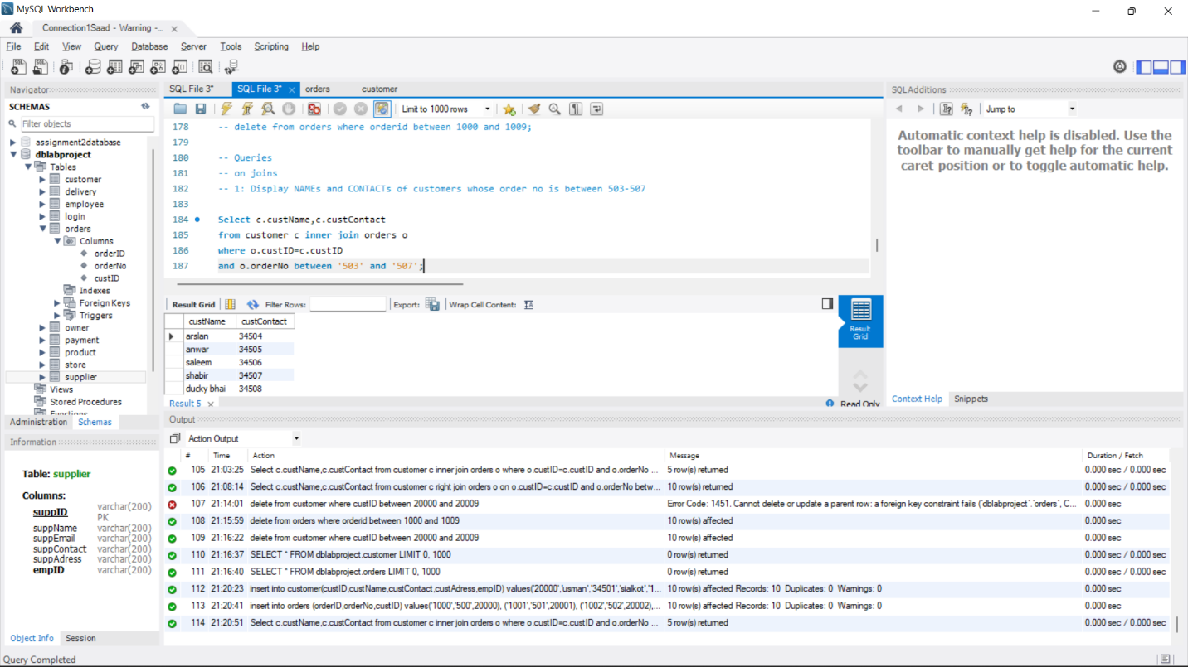

Q2

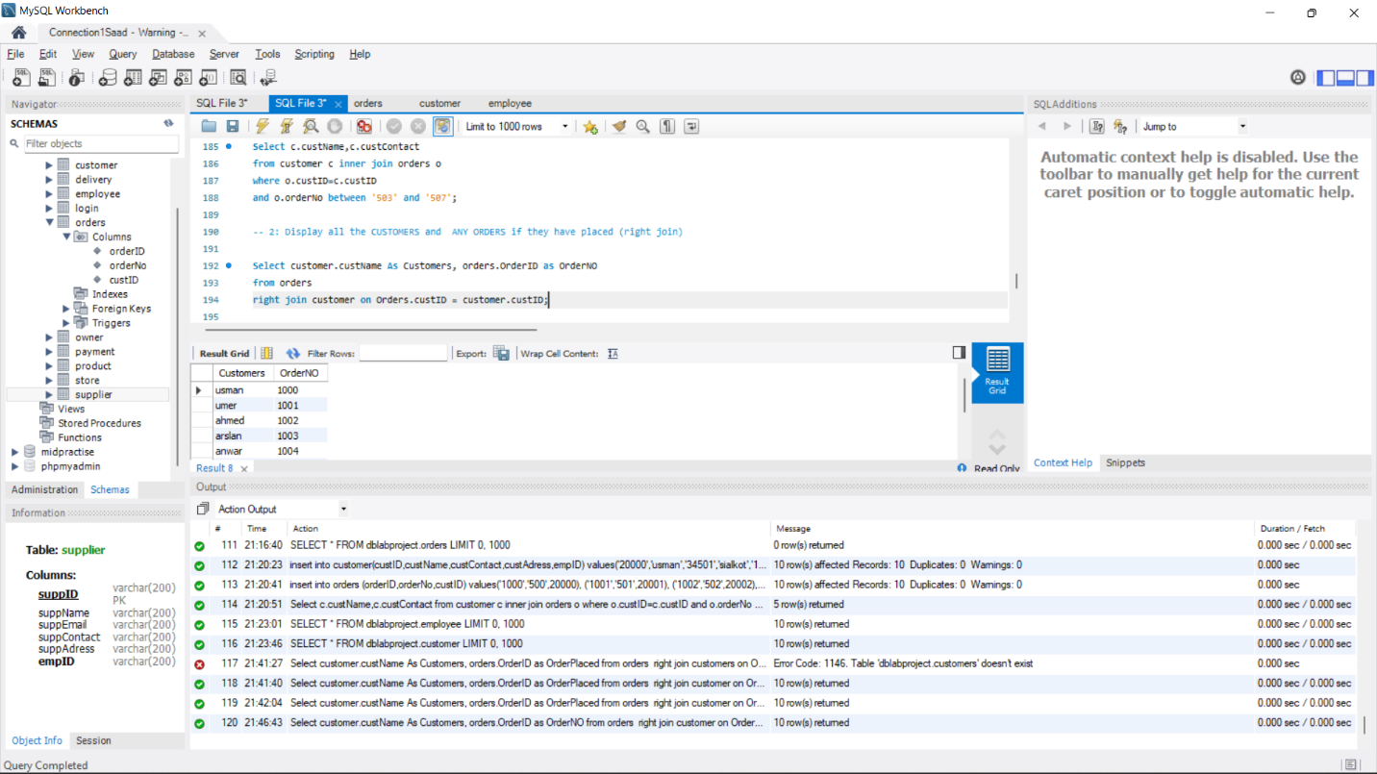

Q3

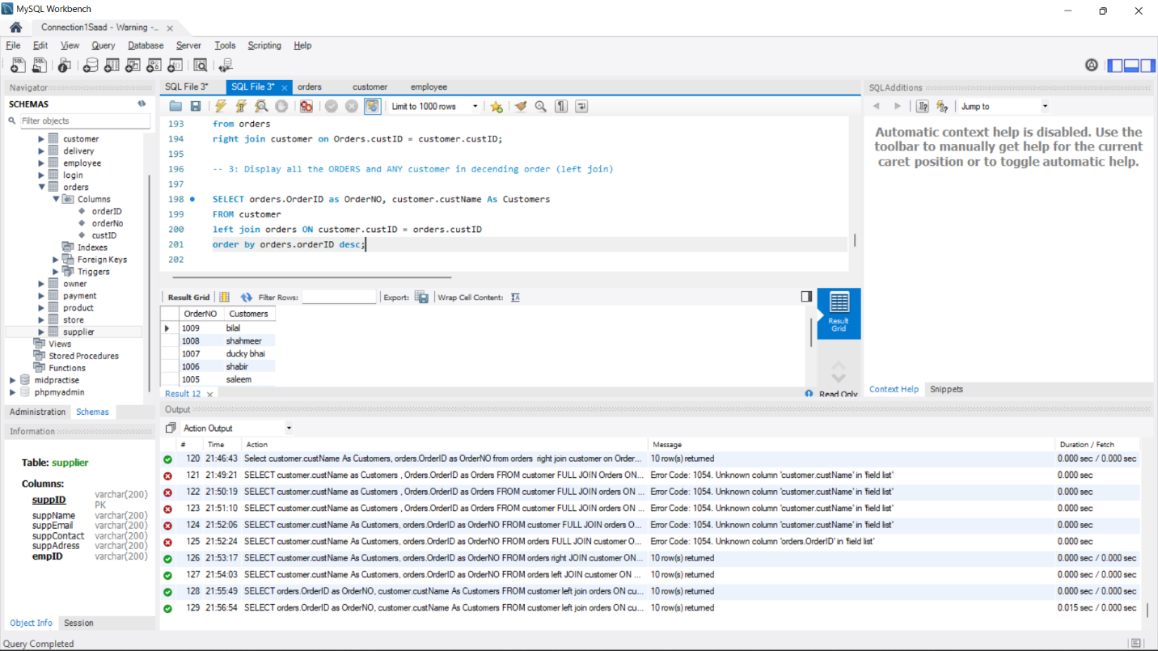

Q4

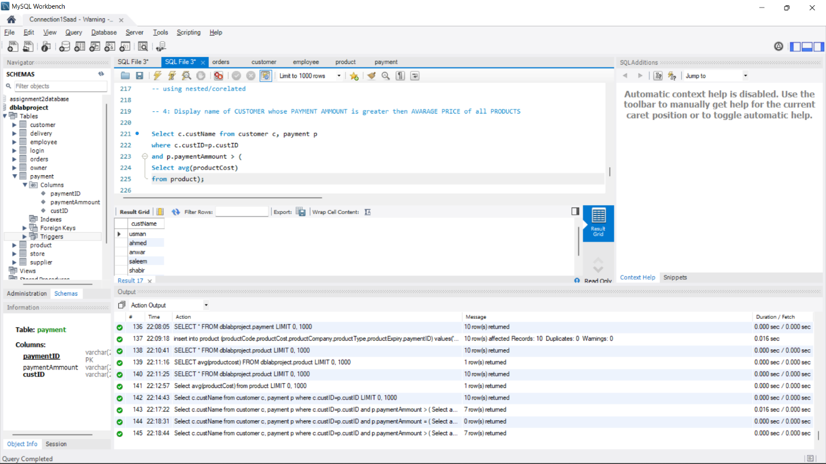

Q5

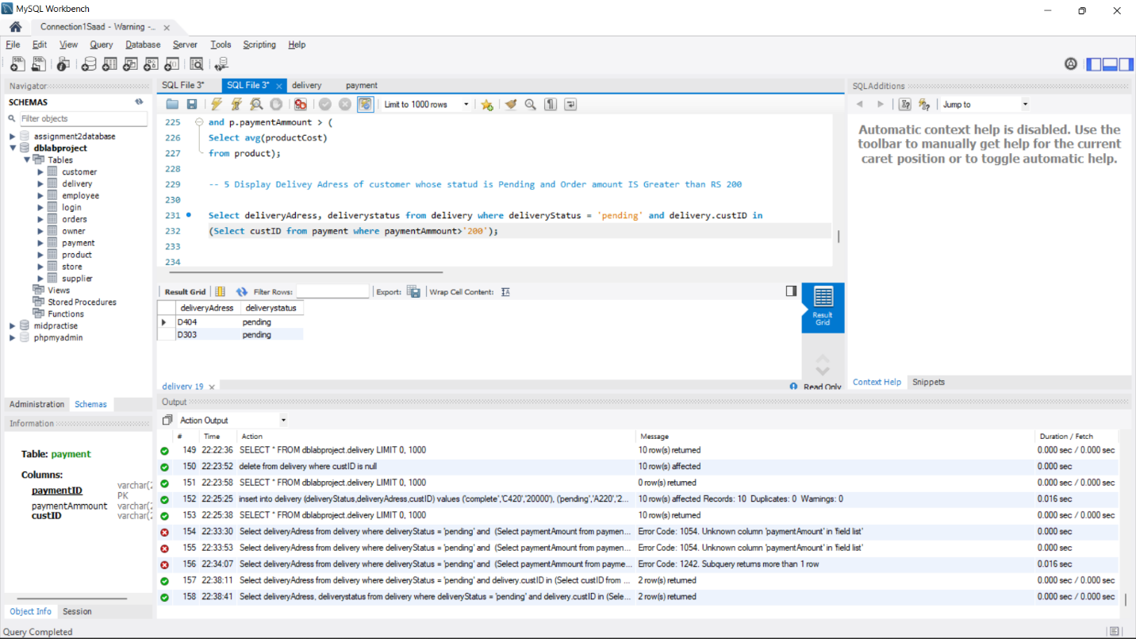

Q6

